**Introduction**

As mentioned in “[Candlesticks The Basics](https://sites.google.com/site/tradingstrategiesschool/module-5-candlestick-chart-patterns-price-action/candlesticks---the-basics)” certain **candlesticks have reversal implications dependent on where they sit in a chart** - **only preceding price action and further confirmation determine the reversal propositions**. In the following section we’ll talk about the most common candlestick patterns and how they go on to form reversal patterns.  All have similar reversal properties, but The **Doji reversal should be considered the more robust** – or at least a near doji (open and close very near).

**When traders use price action to form their trading strategies the reversal must have further confirmation**. Candlesticks are regarded as neutral, bullish or bearish, so need this further confirmation to signify a reversal – otherwise they just form support and resistance levels (which is useful in itself), or confirm a “continuation pattern” in the trend. The actual reversal indicates that buyers/sellers overcame prior selling/buying pressure and we'll discuss this confirmation below. You'll also learn in the following paragraphs that some candlestick patterns consist of 1, 2 or 3 candlesticks, so let's discuss this further...

**The Star Position Pattern (3 Candles)**

The **Star Position Pattern is a reversal pattern, made by two candles** **and a reversal confirmation candle** -  a long body, a short body that gaps beyond the first candle (up or down depending on the prevailing trend). It then needs a reversal confirmation.  We can see this at work in the below chart where the star in a down trend is called the morning star and in an up trend it's called an evening star.

[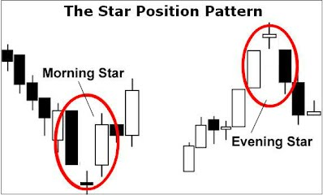](https://sites.google.com/site/tradingstrategiesschool/module-5-candlestick-chart-patterns-price-action/candlestick-reversal-patterns/star%20position.JPG?attredirects=0)

The Star Position Reversal Pattern

The **star candle gaps up or down from the preceding candlestick**.  The preceding candlestick will usually have a long candle body, while the star candle will have a small body. The star can be filled **or** hollow in a bearish **or** bullish trend reversal. **Doji, hammers, shooting starts, spinning tops all have small bodies and can be seen in the star position**(See [Candlesticks - The Basics](https://sites.google.com/site/tradingstrategiesschool/module-5-candlestick-chart-patterns-price-action/candlesticks---the-basics) for definitions). **After the star candle there must be a reversal candle to complete the confirmation**.  This star position isn’t easy to find, so pay special attention to it when it happens. Volume plays it's part in the reversal. Ideally there should be reducing volume going into the star and increased volume on it's reversal confirmation candlestick. Pay particular emphasis on the volume of the confirmation candlestick.

**The Morning & Evening Doji Star Reversal Pattern (3 Candles)**

As stated in “[Candlesticks - The Basics](https://sites.google.com/site/tradingstrategiesschool/module-5-candlestick-chart-patterns-price-action/candlesticks---the-basics)”, Doji on their own only indicate buyers and sellers are balanced and cancel each other out or that price action is limited with indecision. The Morning and Evening Doji Star Reversal is just another version of the Star Reversal Pattern above, but maybe more meaningful to the reversal. **The real relevance of doji depends on the preceding trend or candlestick and it's reversal confirmation**. A doji in a ranging market doesn’t tell us anything other than indecision. However, **after a trend or after a long candlestick the doji signals that the trend or price action is starting to weaken**.

**[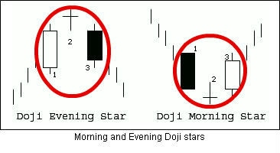](https://sites.google.com/site/tradingstrategiesschool/module-5-candlestick-chart-patterns-price-action/candlestick-reversal-patterns/morning%20and%20evening%20doji.JPG?attredirects=0)**

**The shape of the doji may differ during the reversal**, i.e. in our above example the cross and inverted cross may be switched for any Doji as highlighted in [Candlesticks - The Basics](https://sites.google.com/site/tradingstrategiesschool/module-5-candlestick-chart-patterns-price-action/candlesticks---the-basics) - (common, long-legged, dragonfly, gravestone, cross and inverted cross are all interchangeable) . When looking for the reversal patterns chartists look for a Doji (or a short body candle at the very least) after a trend then require there to be a reverse confirmation candle (or gap up or down depending on the previous trend). The 3rd candle needs to extend at least half way through the 1st candle for the reversal to be robust. Both the Morning Doji Star and Evening Doji Star are charted above.  Basically, trend activity is interrupted by indecision, leading to a reversal. The forces of supply and demand are starting to equal out and a reversal may be about to occur. Once again, further technical analysis and increased volume on the confirmation candle (3rd candle) is needed to verify any reversal. It's also better to see reduced volume on the the 1st candlestick.

**The Harami Position Pattern (2 Candles)**

The pregnant woman (Japanese translation "**Harami") is also a reversal pattern** and is more common than the star position. Basically it is two candlesticks, plus a third candlestick confirming the reversal - the 1st being a long bodied candlestick, the 2nd body nestling within the body of the 1st and the 3rd confirming the reversal. This is graphically represented in the below chart.

[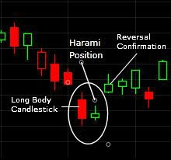](https://sites.google.com/site/tradingstrategiesschool/module-5-candlestick-chart-patterns-price-action/candlestick-reversal-patterns/harami.JPG?attredirects=0)

The Harami Position Reversal Pattern

The shadows of the 2nd candle don’t have to be confined within the 1st candles body, but it helps. This is a bullish **or** bearish reversal depending on the previous trend and can be formed by either a hollow **or** filled body in any combination (The 2nd candle in a harami can also be a doji candlestick). The close of the Harami in a bullish pattern (indicated above) must be higher than the close of the longer filled candlestick. A bullish Harami will be found at the bottom of a downtrend. Bearish is the exact opposite and found at the top of an up trend.

Saying that the Harami can come in any combination of hollow or filled is true, but **a Harami with a hollow 1st candle is considered more bullish and a Harami with a 1st filled candle is considered more bearish**. This shows a sudden resurgence in buying/selling pressure prior to a consolidation, then the reversal. A Harami with a 1st filled candle can still be bullish if it’s found at the bottom of a down trend.  they also occur more often than the more bullish hollow 1st candle Harami. The 1st filled candle indicates that there are still plenty of sellers in the market, but then a small candle that kicks up a little from the previous close indicates that buyers are waiting in the wings for a potential reversal.  Ideally there should be light volume on the second candle and high volume coming out of pattern - on the reversal candle confirmation.

**Long Shadow, Small Body Reversal Signals (1 Candle)**

The long shadow candlesticks consist of one long shadow a small body (at least ½ the length of the shadow) and a small 2nd shadow (or no 2nd shadow). **There are 4 main long shadow candlesticks – The Hammer, Hanging Man, The Inverted Hammer and The shooting star.** The Hammer and The Hanging Man both have long lower shadows and can have filled or hollow bodies, while the Inverted Hammer and Shooting Star have long upper shadows and also have filled or hollow bodies. **The longer the shadow is, the more relevant the potential reversal.**All 4 can be doji. As with all candlestick patterns it's better not to take them in isolation - a prior trend needs to be present and there needs to be subsequent confirmation.  
  
In the below charts we can see examples of these long shadow reversals. These reversal signals will need further confirmation in the shape of a good reverse candle or a gap to the reverse.  Further technical analysis, like volume (as we'll explore below) will also be helpful.  We'll also discover in further sections that these signals can also confirm support and resistance areas

[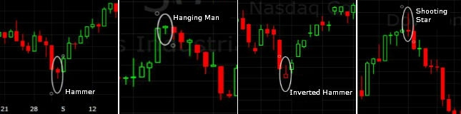](https://sites.google.com/site/tradingstrategiesschool/module-5-candlestick-chart-patterns-price-action/candlestick-reversal-patterns/long%20shadow%20reversal.jpg?attredirects=0)

Long Shadow Reversal Signals

**The Hammer and Inverted Hammer are bullish in reversal** after a decline in trend and can signify support.

**The Hammer** - sellers drove prices down before buyers came back into the market to force the session higher. This signifies demand and supply are almost in balance at the end of the period, but a potential reversal maybe due after a bull charge. Further confirmation with a subsequent bull candlestick or jump up is needed to confirm this reversal.  Confirmation is needed because as the low of the shadow shows, plenty of sellers remain in the market.

Ideally volume should increase on the day of the hammer and the longer the wick the better - both bring an increased chance of reversal.  Also, volume on the next candle confirmation is needed. Although the body can be hollow or filled, a hollow body brings slightly more bullish implications

**The Inverted Hammer** indicates buying pressure during the session, but bears eventually won the day driving price back down. However, bears are still in the market and bulls are definitely present, so further price action to the upside in the next trading session can confirm a bullish reversal.

Again, increased volume on the bullish buying candle confirmation is needed. Also, large volume on the day of the inverted hammer increases the chances of the reversal, especially if we get a reversal confirmation next period. Although the body can be hollow or filled, a hollow body brings slightly more bullish implications

**The Hanging Man and The Shooting Star are bearish indicators**.

**The hanging man**, sellers pushed prices down during this session before bulls recovered, driving price higher. A flag has been thrown, which indicates a near supply/demand balance at the end of the period and a possible reversal. Further price confirmation is required to call this a bear reversal, such as a long filled candle down or gap down.

Increased volume on the reversal confirmation candle is also needed. High volume is also important on the hanging man day - meaning that traders who bought that day will be stuck with losing trades if the signal is confirmed the next day. Although the body can be hollow or filled, a filled body brings slightly more bearish implications

**The shooting Star** opens the session with prices advancing, but bears take hold and drive price down. The ability for these bears to bring price down indicates a potential bearish reversal. Confirmation is seen with a following long bodied bear candlestick or gap down.

Ideally volume should increase on the day of the shooting star and the longer the wick the better - both bring an increased chance of reversal. Also, higher volume on the next candle confirmation is needed. Although the body can be hollow or filled, a filled body brings slightly more bearish implications

**The Spinning Top**

A Spinning Top is a candle where it's shape has a small body with upper and lower shadows of equal length, but with greater length than the body. The spinning top also indicates a reversal after a trend. Again, we require confirmation of the reversal with a subsequent reversal candle of gap up or down.candle. If there's not confirmation then the candle means very little. The candle can be hollow or filled, but greater emphasis can be placed on hollow (or green) for a bullish reversal and filled (red) for a bearish reversal.

[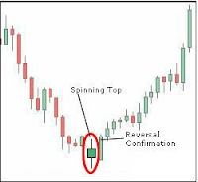](https://sites.google.com/site/tradingstrategiesschool/module-5-candlestick-chart-patterns-price-action/candlestick-reversal-patterns/spinning%20top.JPG?attredirects=0)

The Spinning Top Candlestick

Here, buyers and sellers had various parts of the trading session, but in the end the open and close were relatively close. Also, the spinning top's price action may be contained within a tight range. These two factors indicate indecision, or balance and a possible reversal. If we find the spinning top (or any long shadow/doji candle) in a range we can ignore it, as it’s just confirming the ranges indecision. You may find spinning top's with longer shadow's and small bodies. If this is the case then you may want to treat them like "[Long-Legged Doji](https://sites.google.com/site/tradingstrategiesschool/module-5-candlestick-chart-patterns-price-action/candlestick-glossary)". With regard to volume, you really want to see increased volume on the reversal confirmation candlestick. You may also see increased volume on the spinning top itself.

**Blended Candlestick Reversals and their Confirmation**  
  
There's such a thing as Blended Candlestick Formations.  These Blends can indicate reversals after a trend, just as the candlestick reversals we've talked about can. They're formed by taking the open of the 1st session and the close of the 2nd session, while taking the high and low of both the sessions and amalgamating them.  The below graphic shows the result of blending 2 candlesticks.

[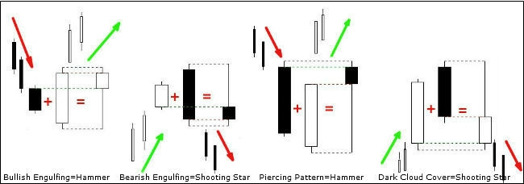](https://sites.google.com/site/tradingstrategiesschool/module-5-candlestick-chart-patterns-price-action/candlestick-reversal-patterns-ii/blended%20candlesticks%201.jpg?attredirects=0)

Blended Candlestick Formations and their Reversal Confirmation

**The Bullish Engulfing Pattern**

**Trading with Engulfing Patterns - by Richard Krivo**

What qualifies as an engulfing candle is fairly simple: as long as the body of a candle engulfs the previous candle in terms of the body and wicks, it would be considered an engulfing candle (Sometimes you may find trader's don't count the wicks). As such, it can indicate that a move in the opposite direction of the candle that was “engulfed”may take place.  
  
In other words, if a bullish candle is engulfed by bearish candle, the higher probability direction to trade the pair will be to short it. If a bearish candle is engulfed by a bullish candle, the higher probability direction to trade the pair will be to buy it.  
  
Remember, just because a trader sees an engulfing candle does not mean that a move in the opposite direction is assured. As far as being certain goes, a trader can be certain that a candle is an engulfing candle, but we can never be certain of what may transpire on the chart going forward.  
  
Keep in mind, as is the case when interpreting candlesticks, a trader cannot make a decision regarding what a candle might turn out to be until that candle is closed. So, always wait for a candle to close before making a trading decision based on whether it's engulfing or not.   
  
**A simple trading strategy** is to take a trade when the engulfing candlestick is in the direction of the main trend. In other words, in a correctional take profits retracement we would look for bullish engulfing candles and in a short bullish correction we would look for bearish engulfing candles.  
  
Should the trade be taken, the stop can be placed below the bullish engulfing candle in an uptrend and above the bearish engulfing candle in a down trend. See more on stop/losses in our Module 7  
  
Lastly, as usual, nothing in trading is a certainty and not all engulfing candlestick patterns will lead to a reversal. Testing a system with proper risk management is essential prior to trading

Really **only useful if found in a downtrend**. We can see the pattern on the left above where the hollow candle body completely engulfs the filled candle body. This pattern doesn’t indicate indecision, but that **buyers are back in the market** - The short bear candle is running out of steam and being engulfed by a strong long bull candle. The longer the white (hollow) candle against the black (filled) candle the greater the chance of reversal and if there is increased volume we’ll also increase our chances of a reversal. The black candle shouldn’t really be a doji as it’s fairly easy to engulf. If the shadow is engulfed, then this is better, but not necessary and finally the shadows on both candles should be small or non-existent. Again, further confirmation is needed for reversal.   
  
This pattern can also confirm a continuation of trend and continued buying pressure. If seen passing through a resistance level then this may confirm a break of resistance. This pattern is valid as long as the body is engulfed.   
  
**The Bearish Engulfing Pattern**   
  
**Only useful in an up trend** and is the exact opposite to the bullish engulfing pattern – it is the 2nd diagram on the left above. The same rules apply here as they did above and we should always look for other confirmation in the form of further price action to the downside (like the three black crows, below) and increased downside volume.  
  
**The Piercing and Dark Cloud Cover Patterns**   
  
These two blends work in the same ways as the previous two. The Piercing pattern is a bullish pattern where the hollow 2nd candle drives up from below the previous filled candle to above half way of the previous filled candle. Both candles should be fairly large bodied with small shadows. If the white candle doesn’t finish above the black candles middle then this isn’t considered bullish. This is the third diagram above. Again, confirmation is required for reversal. Dark Cloud Cover is the mirror image of The Piercing Pattern.   
  
**Three White Soldiers and Three Black Crows Reversal**  
  
Solid Confirmation is found if reversed momentum is followed up with strong corroboration – the most famous of these are the three white soldiers and the three black crows. The 3 white soldiers equal 1 long white (hollow) candle and the 3 black crows equal a long black/red (filled) candle. **Both these blends can be seen in reversal patterns and are used to confirm that the reversal has taken place**.

These two formations will be more prevalent after a long trend that is going through a reversal. Ideally the 3 candles should start within the last candle and close near the high (in the case of the 3 white soldiers) or the low (in the case of the three black crows). In the 3 white soldiers chart below the soldiers are the reversal and in the 3 black crows chart the black crows confirm a spinning top candlestick showing indecision.

[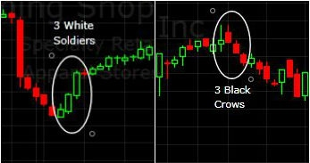](https://sites.google.com/site/tradingstrategiesschool/module-5-candlestick-chart-patterns-price-action/candlestick-reversal-patterns-ii/3%20white%20and%20black%20soldiers.jpg?attredirects=0)

Three White Soldiers & three Black Crows Reversal

**The Use of Other Technical Analysis is Beneficial**

Candlesticks provide an excellent means to identify short-term reversals, but should not be used alone. Other aspects of technical analysis can and should be incorporated to increase reversal robustness. For instance support and resistance, Fibonacci retracement and overbought and oversold oscillators can play an important part in any price action trading strategy. Look how support coincides with a bullish engulfing candlestick pattern and how The Stochastic crosses the bullish 50 line below helping to confirm the reversal.

**How to Trade Candlestick Reversal Patterns**

As we've discussed in all of our Candlestick Reversal Patterns, traders must wait for confirmation prior to trading. This means that they're supposed to **wait until the following day's close to see if the stock reverses**. This is the trade entry point.  Combining candlestick confirmation with other technical analysis, i.e, oscillators, moving averages etc...to gain further confirmation may also be prudent as we've seen above.  However If a stock pulls back to an area of demand (support) and there's a candlestick pattern telling us that buyers are taking control of the stock, then that is all the confirmation some traders need.  The choice is yours and all depends on your threshold for risk.

Let's look at an example trade using the engulfing candlestick pattern.  This is a simple day trading system for example only, using the AUD/USD forex pair, so you may want to research other price action/indicator systems.  You also need to [back tested](https://sites.google.com/site/tradingstrategiesschool/module-10-trading-systems-strategies/manual-back-testing-your-system) all trading systems yourself, to make sure your comfortable with the risks. But I hope you can see how this system can transfer to other candlestick patterns and time-frames?

[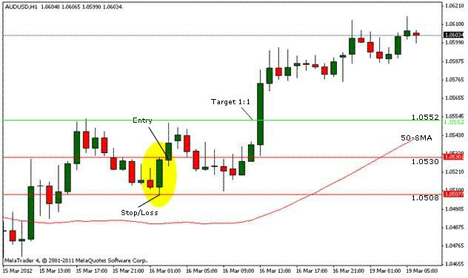](https://sites.google.com/site/tradingstrategiesschool/module-5-candlestick-chart-patterns-price-action/candlestick-reversal-patterns-ii/candlestick%20trade.JPG?attredirects=0)

Example Bullish Engulfing/Moving Average Trading System

Our set up  - a 1 hour chart with a 50-period simple moving average

Our system rules - If price is above 50 SMA we're in an up trend so we buy. In an up trend we're on the look-out for bullish engulfing candlesticks. In a down trend (price below 50 SMA) we look for a bearish engulfing pattern and we sell.

Entry - 1 pip above the high of the bullish engulfing or 1 pip below the bearish engulfing on the next candle

Risk Management - Stop/Loss placed 1 pip below the bullish engulfing in an up trend, or 1 pip above the bearish engulfing in a down trend

Take Profit - We're looking for a reward to risk ratio of 1:1.

So, Price is above 50 SMA, so we need to be looking to go long. I've highlighted the bullish engulfing candle in the yellow oval on our 1 hour chart.  We enter long 1 pip above the bullish engulfing candle on the next candle at 1.0530 (3am, 16th Mar) and place a stop/loss at 1.0508. If our Target take profits ratio is 1:1 then our target price is 1.0552 (i.e the equivalent distance from entry to our risk - 1:1). We reach this at 1pm on the 16th - 10 hours later.

Well, I hope you get the just of how to trade candlestick patterns and begin to see how you can develop your own system? Of course many trades will go against you!  Remember this is a simple system. Yours may incorporate different reward to risk factors and support and resistance etc... See the [Trading Flowchart](https://sites.google.com/site/tradingstrategiesschool/system/errors/NodeNotFound?suri=wuid:gx:789c078d00776c3d) for more ideas.  But you may want to keep it simple - Simple systems do make money.  Visit some blogs and sites to view some other systems.